Clearinghouse Mechanism for Adaptation

Contract nr: Nº 070307/2010/569200/SER/C3

Development of the Climate Change Impacts Vulnerability and Adaptation Clearinghouse
Implementation Phase 3

Theming Guide

Version 1.0
March 7, 2012
Wageningen, the Netherlands



Alterra
Wageningen University and Research;
Droevendaalsesteeg 3, 6708 PB
Wageningen, The Netherlands

In cooperation with


Version history

Version | Date | Description
1.0 | 07/03/2012 | Final

Table of contents

1 Overview 2
2 Templates 3
3 Portal templates 3
4 Layout templates 4
5 Web content 5
6 Portlet specific styles 6
7 Page specific styles 7
8 Inline styles 8

Overview

The theme, called “ace-theme”, is created by using the Liferay Plugins SDK in Eclipse. With the help of the SDK you can generate a new theme and choose if you want to start blank or base the theme off one of the included default themes.

The theme used in CLIMATE-ADAPT is based on one the default themes. This provides a style for the complete website and all default Liferay applications.
The anatomy of the theme folders consists of the following:

/ace-theme/
/docroot/
/WEB-INF/
liferay-plugin-package.properties
/_diffs/ (subfolders not created by default)
/css/
/images/
/js/
/templates/
/css/
application.css
base.css
custom.css
dockbar.css
extras.css
forms.css
layout.css
main.css
navigation.css
portlet.css
/images/
(many directories)
/js/
main.js
/templates/
init_custom.vm
navigation.vm
portal_normal.vm
portal_pop_up.vm

The four main categories are the CSS, js, images and templates folders. You will also notice the “_diffs” folder, which has a special meaning in Liferay theme development. All the overrides to the generated files, you make in this folder. For example: if you want to override the main.js file, you'll have to create a js folder and copy the existing main.js file into it. On the moment of building the theme, all the files in the _diffs folder will replace the corresponding files in the css, js, images and templates folders. In the case of CSS, Liferay advises to make all changes in the custom.css file (in the _diffs/css folder). For more general info on Liferay themes, check these wiki pages on liferay.com.

Templates
These are the main building blocks for any page in a Liferay environment. Templates are written in HTML and Velocity, and they exist on different levels, which is depicted in illustration 1.

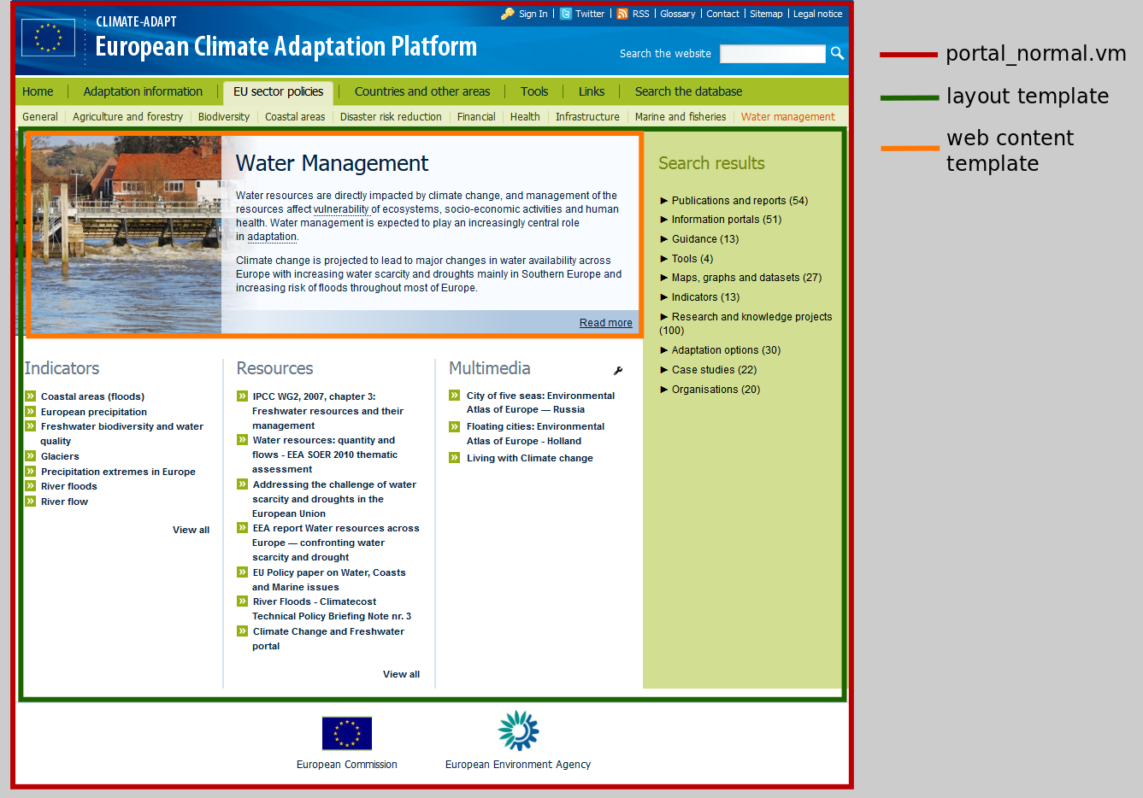
Figure 1 – Overview templates

Portal templates

The portal template “portal_normal.vm” determines the layout of the different sections on any page, such as the header, body, footer. For more detail on how these templates work see the official documentation. The portlet.vm file has a similar purpose, however on a portlet level.

Layout templates

Layout templates determine the layout of the main content region on the page. CLIMATE-ADAPT required a number of custom layout templates:

- Ace layout 2, used on the Adaptation Measures page.
- Ace layout 3, used on most of the Adaptation information and on all sector pages.
- Ace layout 4, currently not used in the portal.
- AST, used on all Adaptation Support Tool pages.
- FAQ, used on the pages for Uncertainty Guidance.
- Frontpage, used on the frontpage.
- Transnational region, used on all national and transnational region pages.

Illustration 2 shows the 1-1-3 column layout template as used on the sector page “Water management”.

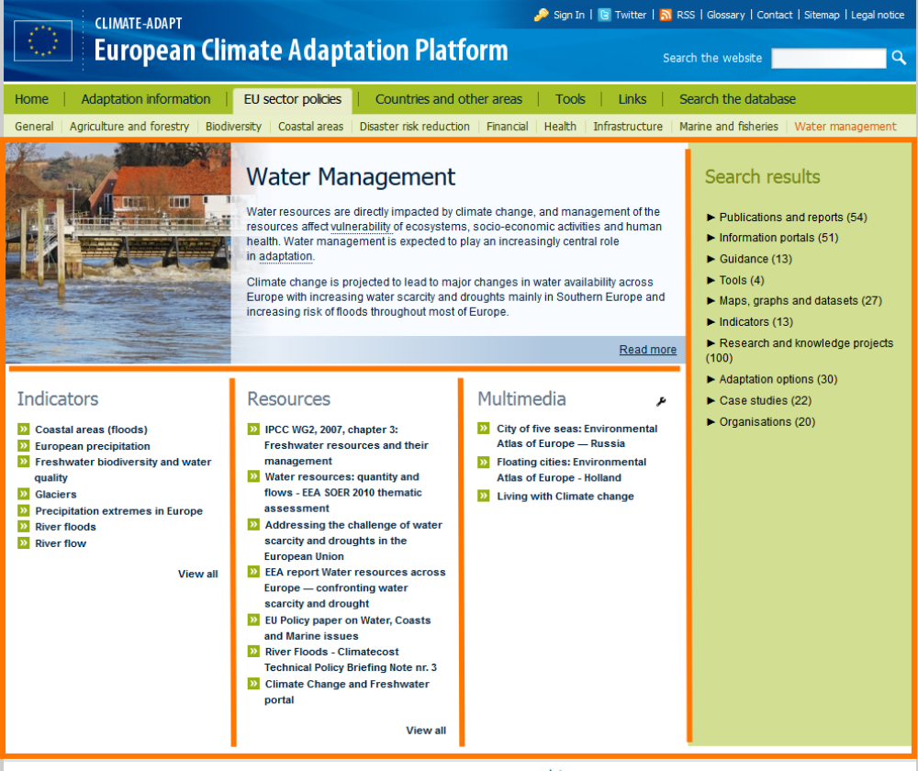
Figure 2 – Layout template as used on the water management page

Web content

Any piece of content in Liferay uses a so-called structure and web content template. A structure defines the fields of the web content, e.g. an imagefield, text or select list. A web content template allows you to translate these fields to an HTML structure. Liferay provides a default structure and template out-of-the-box, which is used in most cases. The following list provides an overview of CLIMATE-ADAPT specific structures:
- Sector main article, used mainly for adaptation information and sector pages.
- AST main text
- National page middle
- Project description
- Project facts
- Transnational regions left
- Transnational regions middle
- Share your info

There are an equal number of templates to match the list of structures above. One exception is made for the observations and scenarios child pages, where an third level in the menu is introduced.

On next page you will find illustration 3, which depicts the relationship between a structure, template and the html page. Example: Structure and web content template of project description page

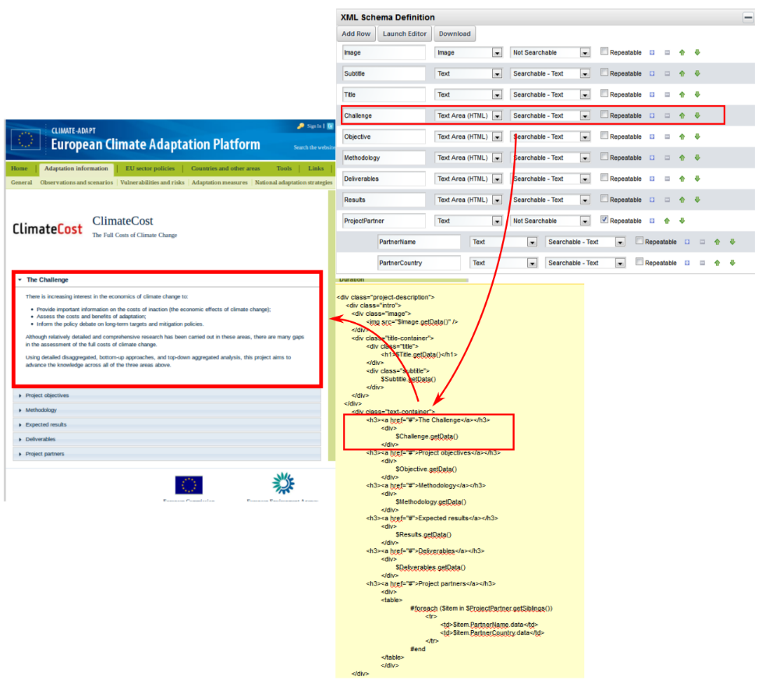

Figure 3 – The relationship between the structure, template and webpage for a research project page

Portlet specific styles

CLIMATE-ADAPT is powered by a custom search backend, which functionality is harnessed in two portlets. On the front-end these portlets sometimes require a different look-and-feel on different pages throughout the portal. Liferay offers the possibility to assign CSS classes on portlet level (by using the “Look and Feel” option of a portlet). The applied CSS code is located in the custom.css file. The following classes are applied on a portlet level
- indicators, for all indicators and resources portlets;
- map-viewer, for the map viewer page;
- sat, for the Case Studies Tool;
- page-title, to transform page titles into the blue big font (for places where an extra web-content template was overkill;
- explore-adaptation-options, a specific case on the adaptation measures page;
- search-discover, for the search page;

The frontpage is a very specific case because of the custom layouts for different web content. It would be absolute inefficient to use web content templates for every specific case. Therefore, for the speedbuttons are done in div's in the web content editor (switch to “source” before editing).
- Check the .frontpage-layout classes for more info in the custom.css;
- db-search-fp is used for the search portlet in the middle of the frontpage (“search the database”);

Illustration 4 shows the application of portlet specific styles for the indicators portlet on the sector page “Coastal areas”.

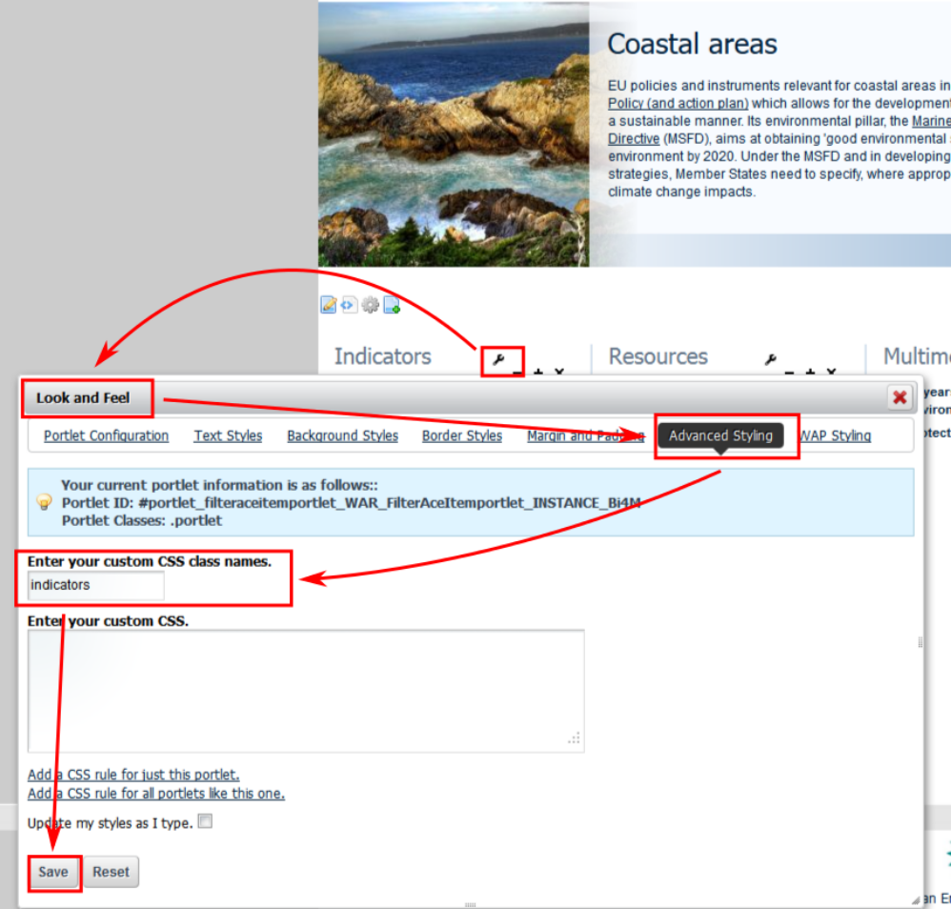

Figure 4 – Portlet styles applied for the indicators portlet on the sector page "Coastal areas"

Page specific styles

Liferay allows javascript to be applied on a page level. The whole portal is based on a fixed width of 984 pixels. For maintenance work it is more comfortable to have a bit more width available. This is done by setting the page-width to 1100 pixels throughout the page settings (Manage > Page > Javascript). Page specifc styles were only used for the maintenance pages.

Illustration 5 shows the javascript applied specificly for the ace-item maintenance page.

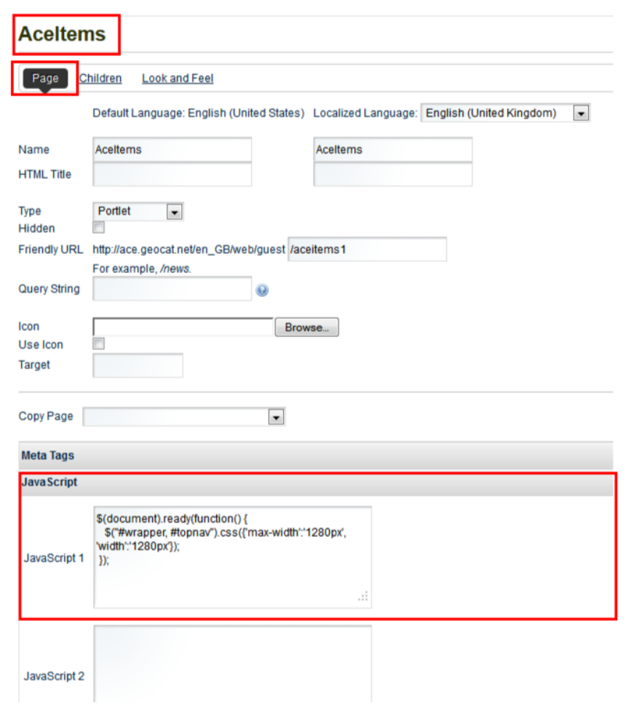
Figure 5 – javascript applied specificly for the ace-item maintenance page

Inline styles

In very few cases (mostly on the frontpage) inline styles were used at places where particular words needed to be emphasized or a link had to be formatted in a certain way. The applied CSS class is defined in the custom.css file.

An example is the double arrow in front of the read more link on the frontpage. This was achieved by applying the class “double-arrow” to the <a> tag in the web content editor.

